# **JSX Deep Dive**

## JSX, Components and Elements

JSX is a syntax extension to JavaScript that React uses to describe what the UI should look like. However, even though JSX looks like HTML, it's essentially a more powerful abstraction that combines both markup and business logic into an entity called a component.

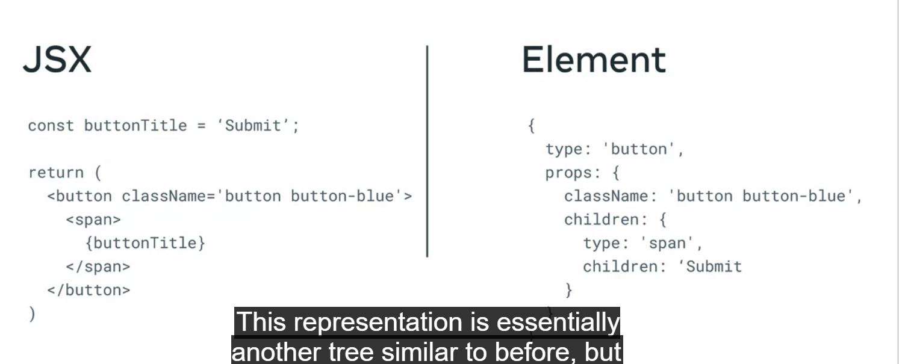

When react analyses your rendering methods from all your components, it takes the whole JSX tree, starting from the root and creates an intermediary representation. This representation is essentially another tree similar to before, but where each node instead of being JSX is a plain object describing a component instance or dom node and its desired properties. This plain object is what React defines as an element. An element is just a way to represent the final HTML output as a plain object. It consists primarily of two attributes, type and props.

Type defines the type of node such as a button and props encompass all the properties the component receives in a single object.

When react creates the entire element tree starting from the root, the root element specifies all the child elements as the children prop. And each child element does the same thing until it reaches the end of the tree.

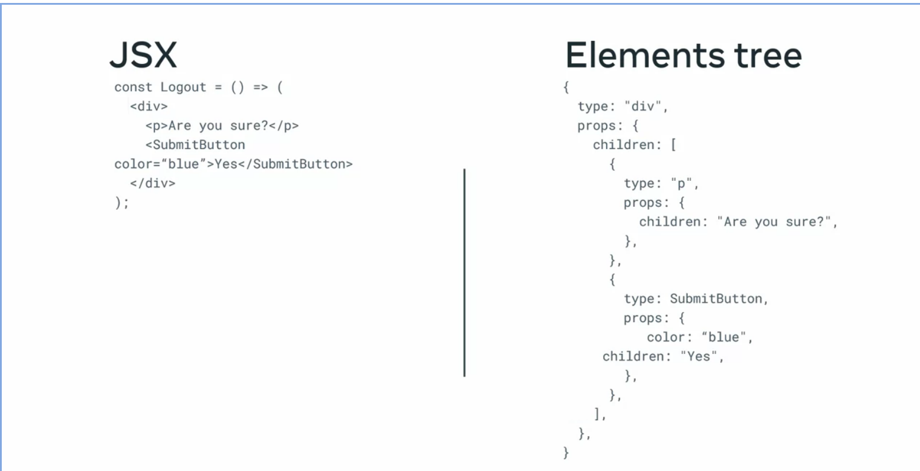

*Which of the examples below are valid types for Elements? Select all that apply.*

* *type: "button"*
* *type: "div"*
* *type: DeleteButton - where DeleteButton is a React component.*

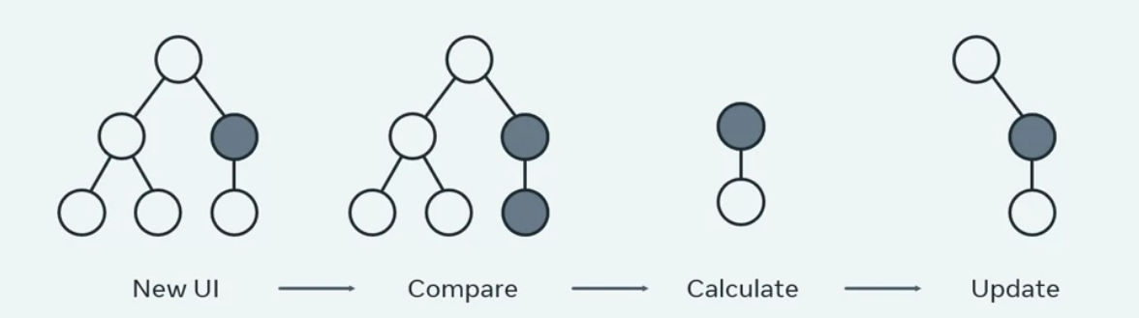

## The importance of performance to software development

n/a

## Component composition with children

When designing React components, one of the most important properties developers tend to overlook is the children prop. The children prop which is a special property all components have, is the foundation for the React powerful composition model.

There are two main features that enable component composition; containment and specialization.

Containment refers to the fact that some components don't know their children ahead of time. This is especially common for components like a sidebar or a dialog, where they delimit a specific area in your UI to contain other elements. You can think of them also as generic boxes. In case you don't know, a dialog is a type of modal window where the rest of the UI is disabled until the modal is addressed and interacted with. For these component boxes, the recommended approach is to use the children prop to pass children elements directly as their content.

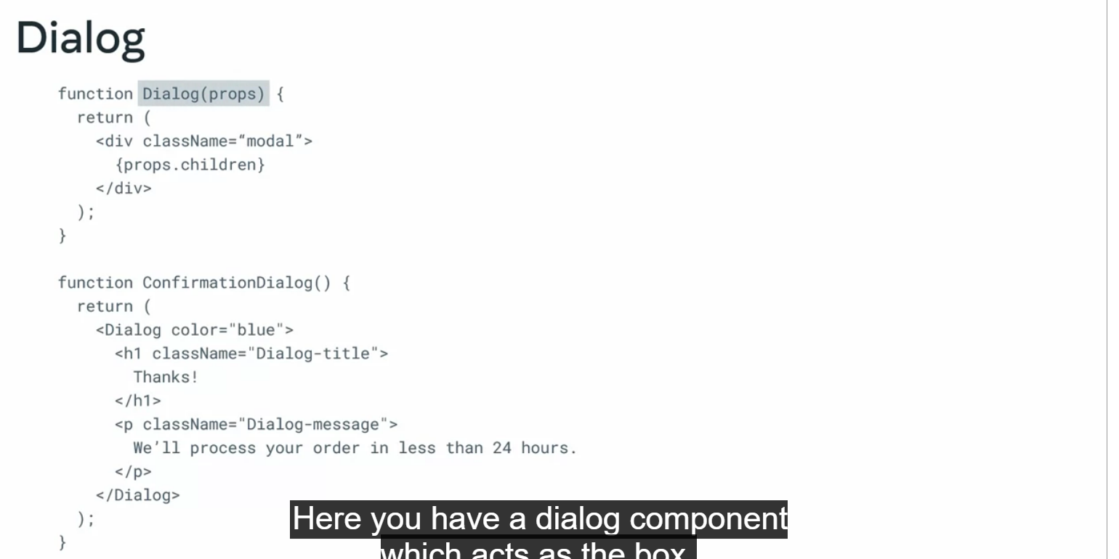

Specialization defines components as being special cases of other components. In this example, the confirmation dialog is a special case of dialog.

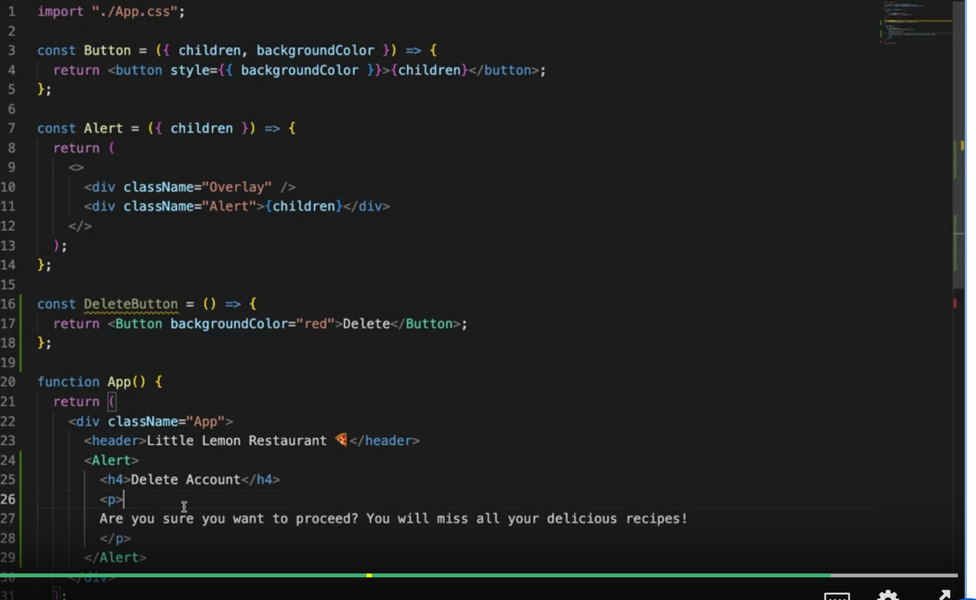

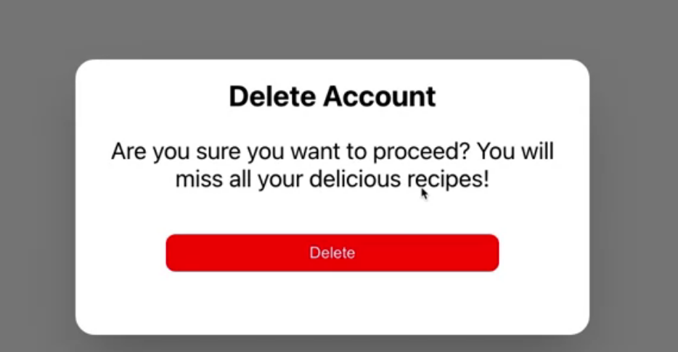

*Which of the statements below clearly states the definitions of Containment and Specialization? Select all that apply.*

* *Containment refers to the fact that some components don’t know their children ahead of time.*
* *Specialization defines components as being “special cases” of other components.*

## Manipulating children dynamically in JSX



Let's explore the first of these APIs, React.cloneElement in more detail. This is part of the react top-level API and it's used to manipulate and transform elements. Top-level API refers to the way you would import those functions from the react package. You can either import react as a global object and the top of your file and access them as methods on that object. Or alternatively as a named import.



React.cloneElement effectively clones and returns a new copy of a provided element. The first argument is the react element you would like to clone, and the second argument is the prompts that will be added and merged with the original props passed into the component.

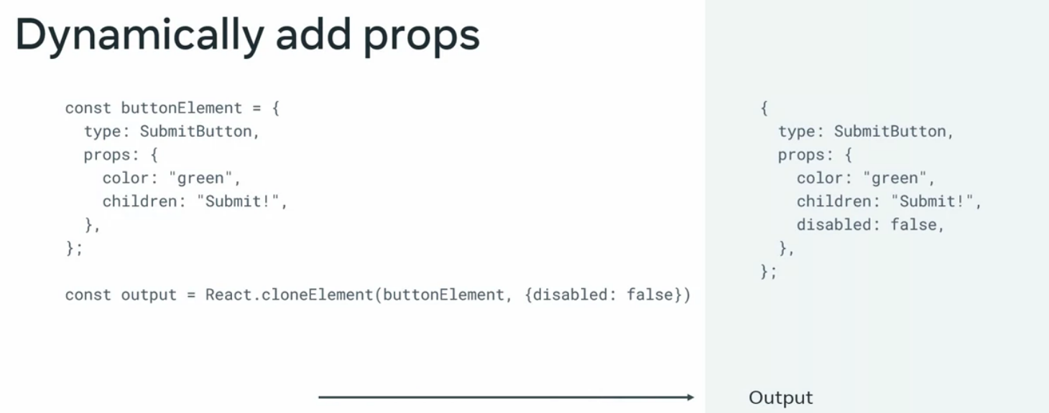





Another important top-level API useful for children manipulation is react.children, which provides utilities for dealing with the props.children data structure. The most important method is the map function. React.children.map is very similar to the map function from arrays and invokes a function in every child contained within its children prop, performing a transformation and returning a new element.

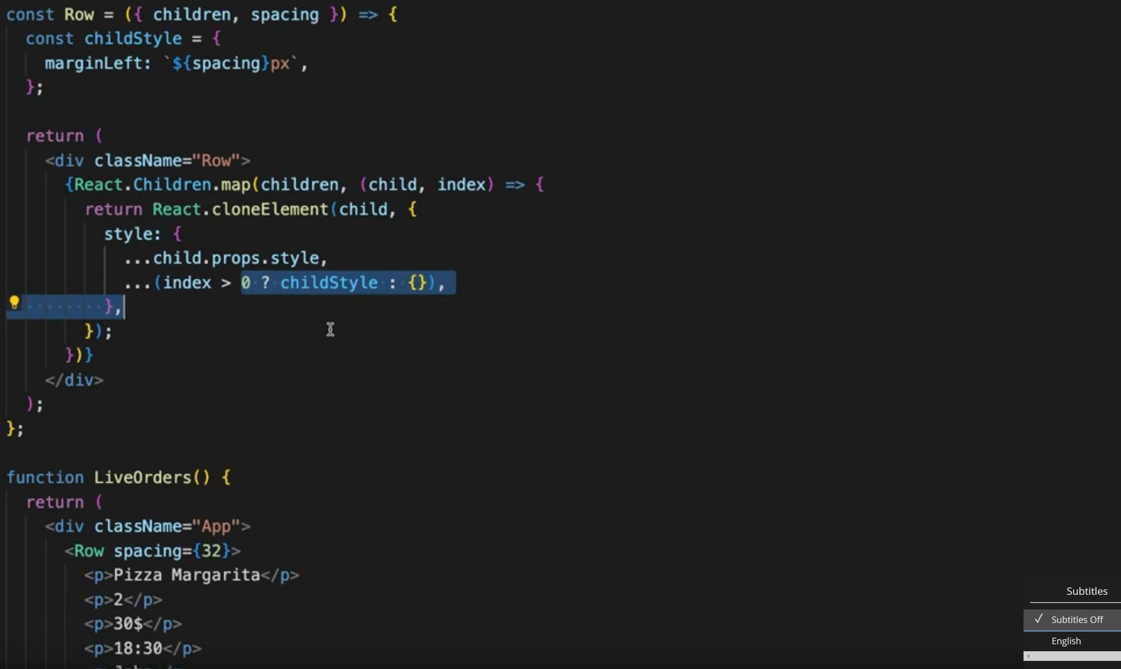

*Which of the following operations does the React.cloneElementAPI enable a parent to perform? Select all that apply.*

* *Add to children properties*
* *Modify children properties*
* *Extend the functionality of children components*

## Spread Attributes

Copying and merging objects are the two main operations you may perform with these operators. For a simple copy of an object, this is the syntax required curly braces and the three dots preceding the object to copy.

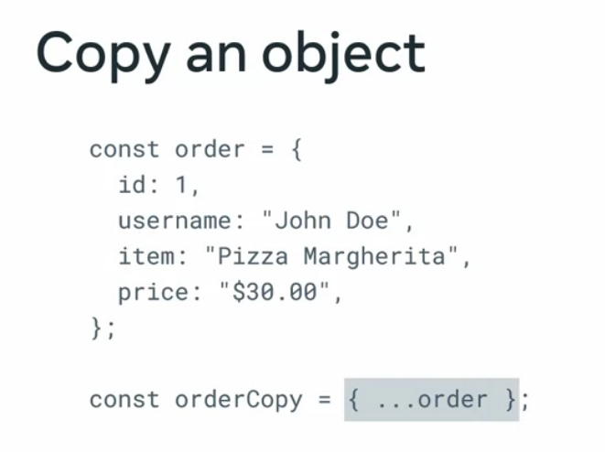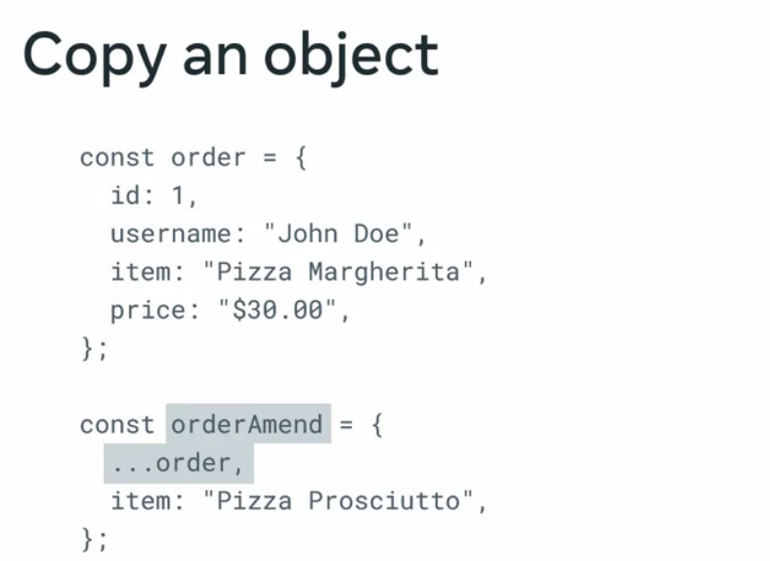

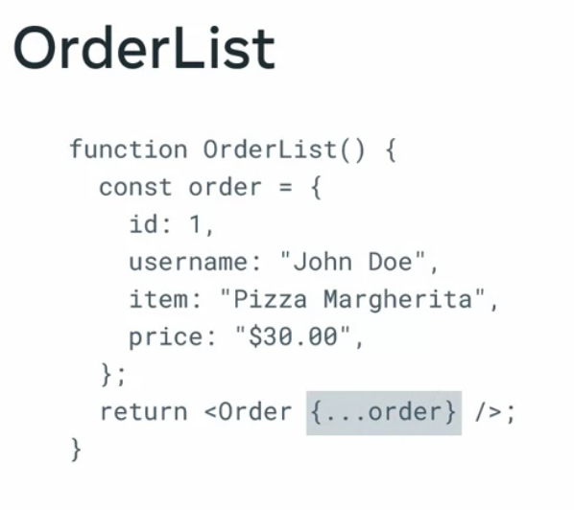

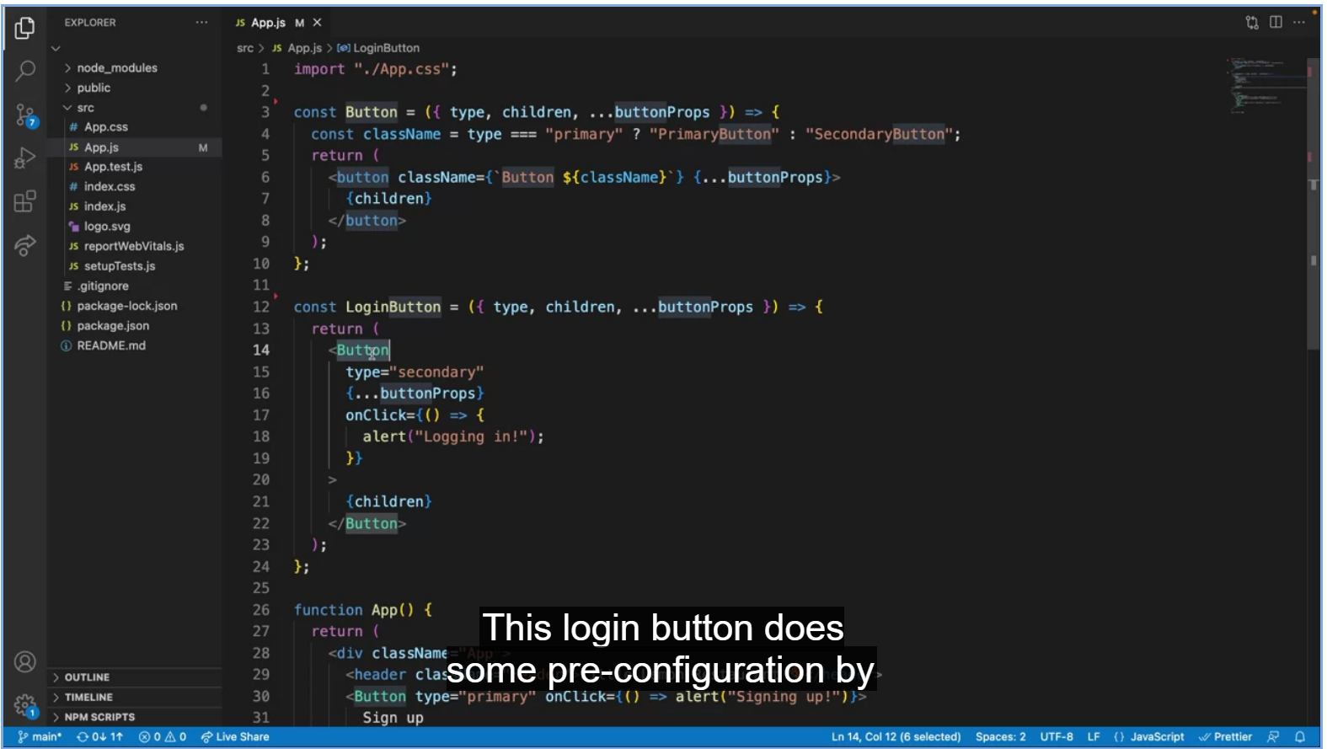

# **Reusing behaviour**

## Cross-cutting concerns in React



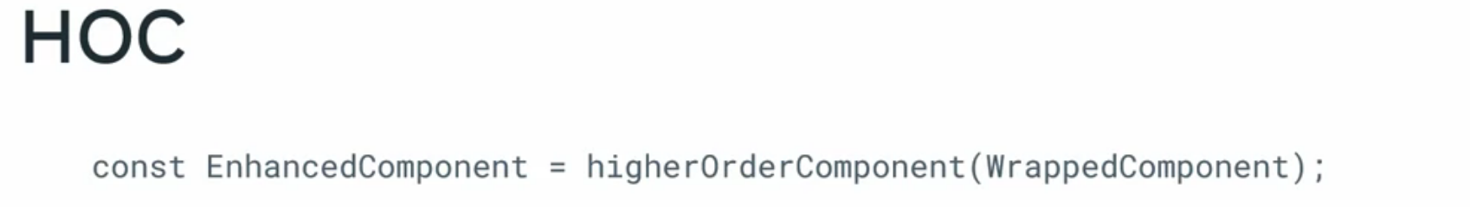

A higher-order component also known as a HOC is an advanced pattern that emerges from React's compositional nature. Specifically, a higher-order component is a function that takes a component and returns a new component. Whereas a component transforms props into UI, a higher-order components transforms a component into another component. In other words, it enhances or extends the capabilities of the component provided.

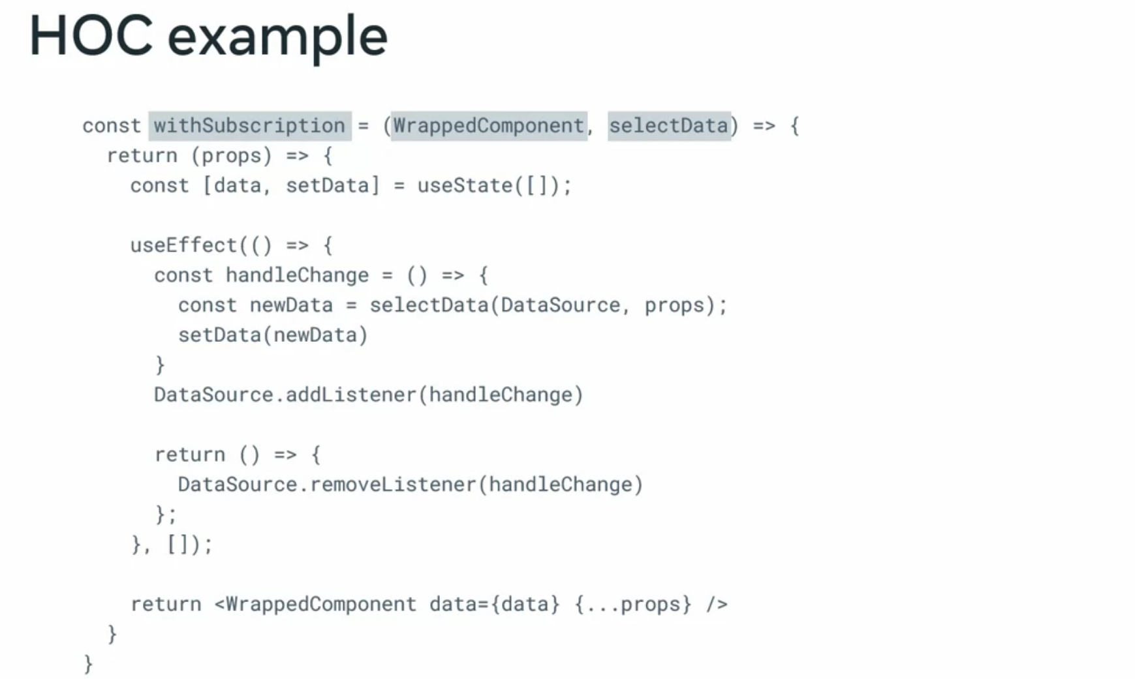

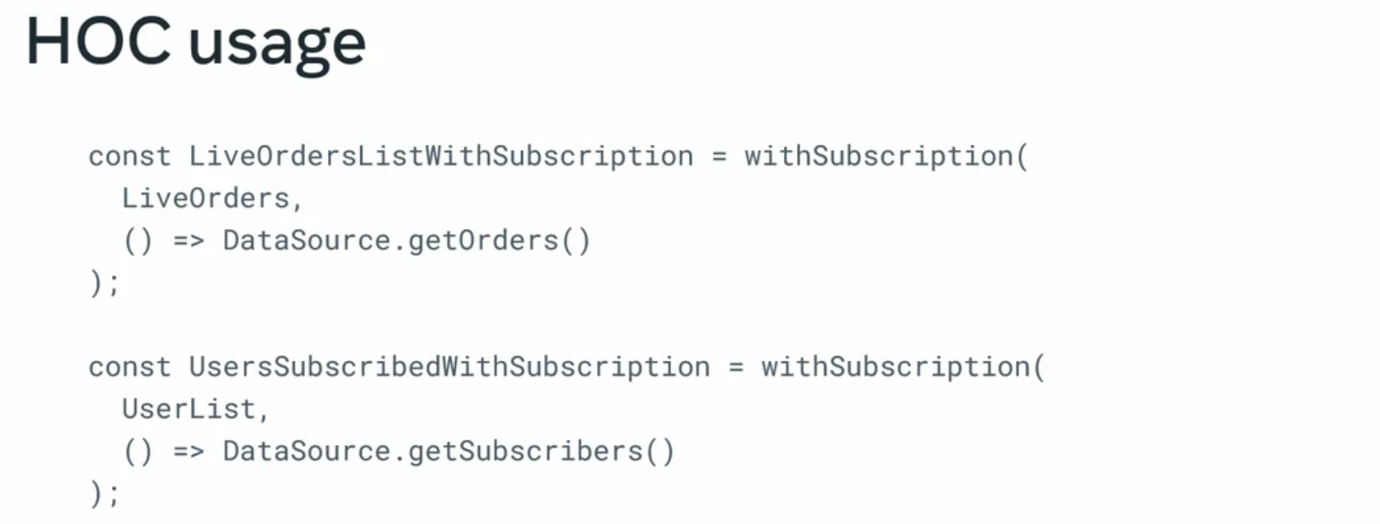

*A higher order component (HOC), is an advanced pattern that emerges from React’s compositional nature.*

*What are some of the benefits of using a HOC in your solution?*

* *You can define logic in a single place, share it across many components, and keep them unchanged and stateless.*
* *It enhances or extends the capabilities of the component provided.*

## Create a HOC for cursor position

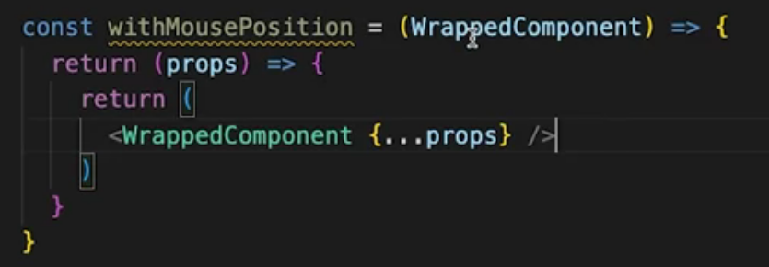

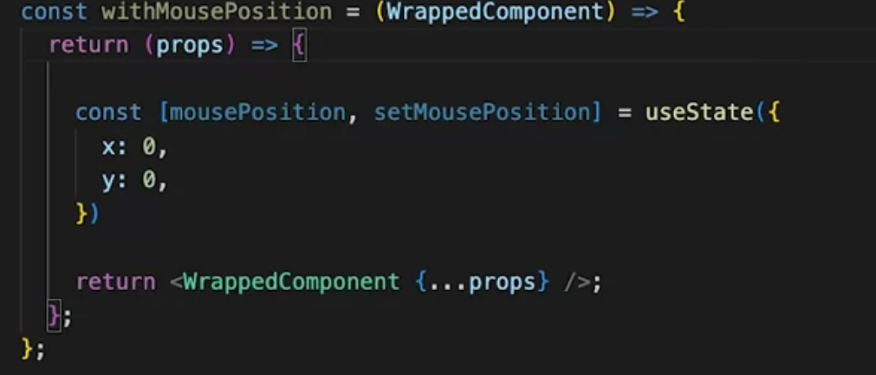

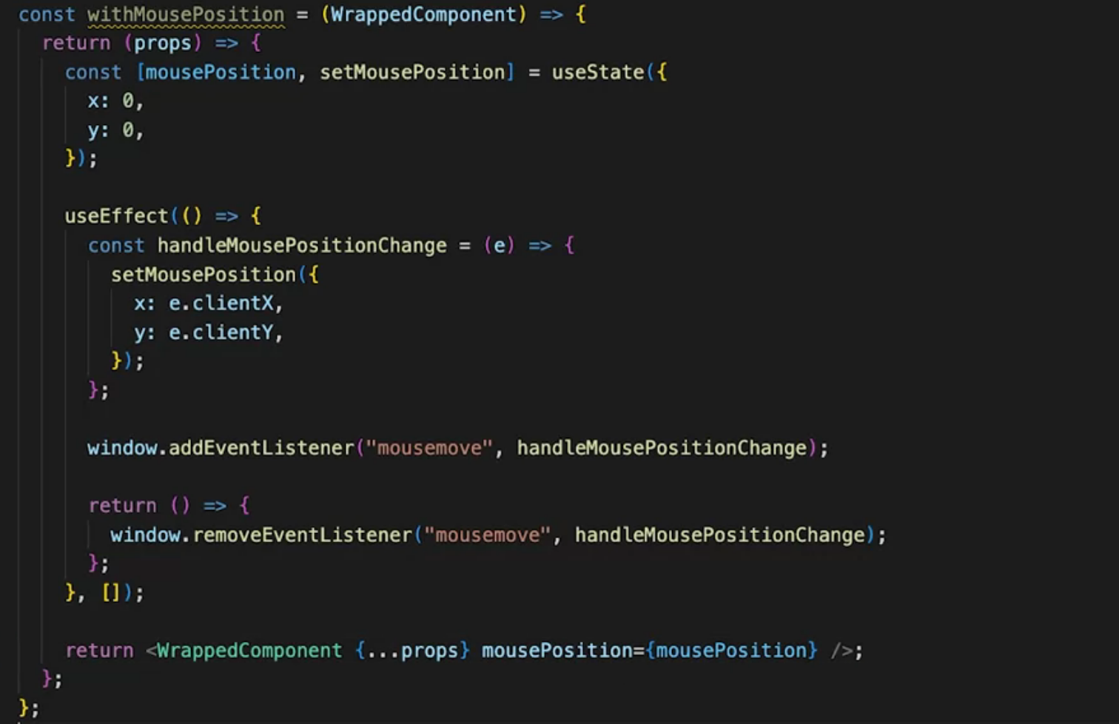

It's important to remove any subscription when your component unmounts. The way to do that is by returning a function from use effect and then performing any clean-up needed.

*When defining a HOC, such as withMousePosition, why is the* ***with*** *part of the HOC name a general convention recommended by React?*

* It expresses the enhancing nature of the technique.

## Render props

render props is also a powerful technique you can leverage to reuse common code. The render props technique is so appropriately named that it's almost self-explanatory. It's about using a prop called render with a particular attribute that it has to be a function. To be more precise, a component with a render prop takes a function that returns a react element and calls that function inside its render logic.

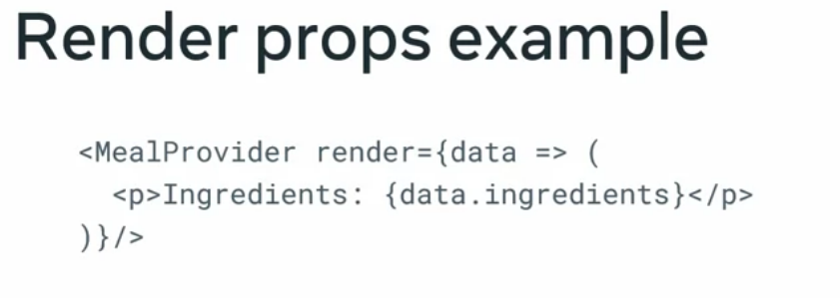

For example, a meal provider component could use this pattern if you remember a higher order component enhanced a component by providing new props into it with render props. However, the new props are injected dynamically as the parameter of the function. 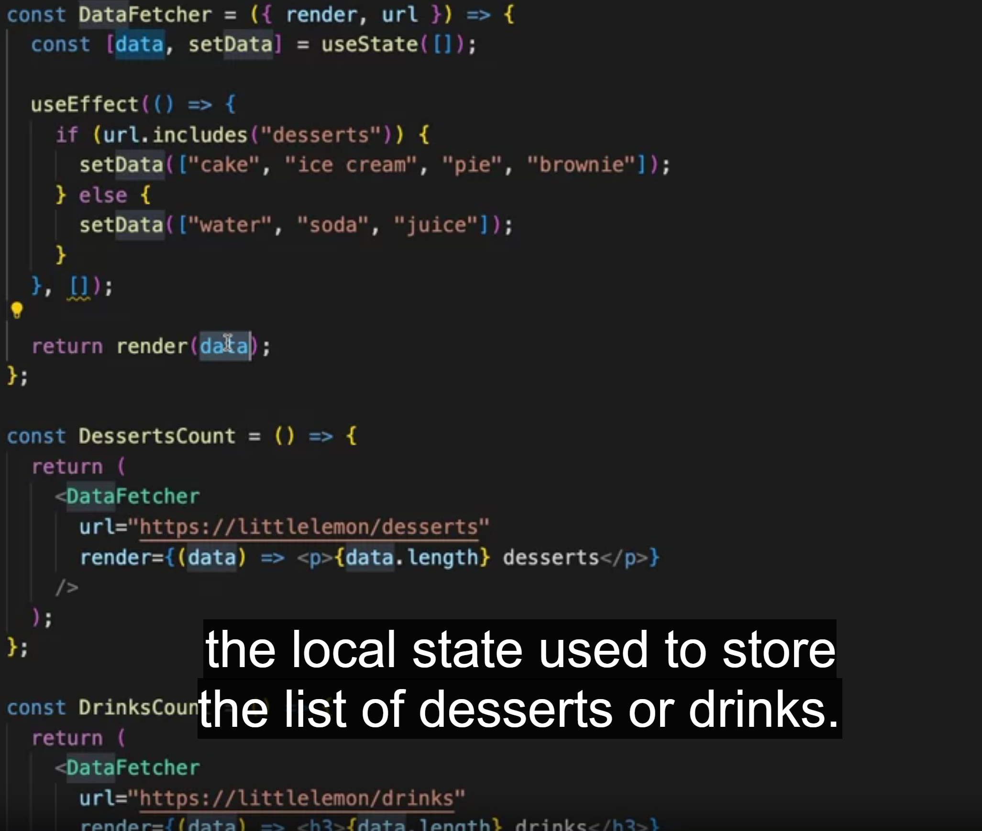

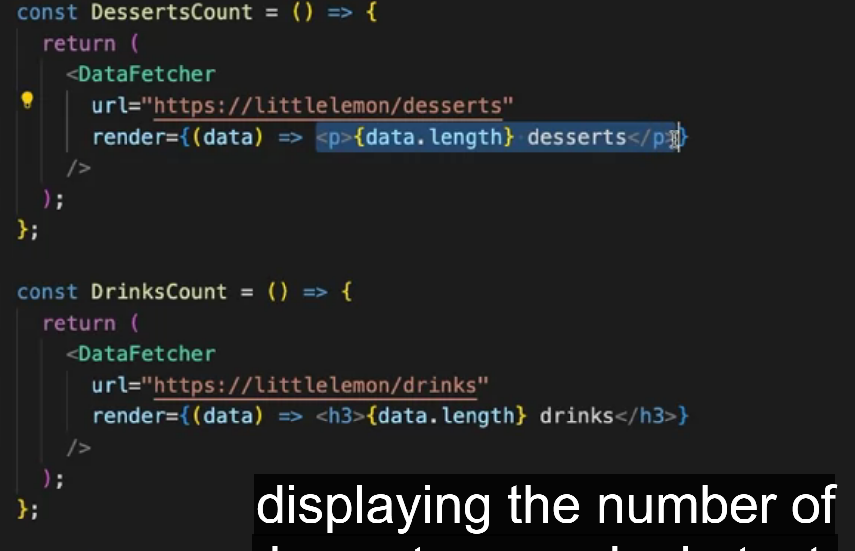

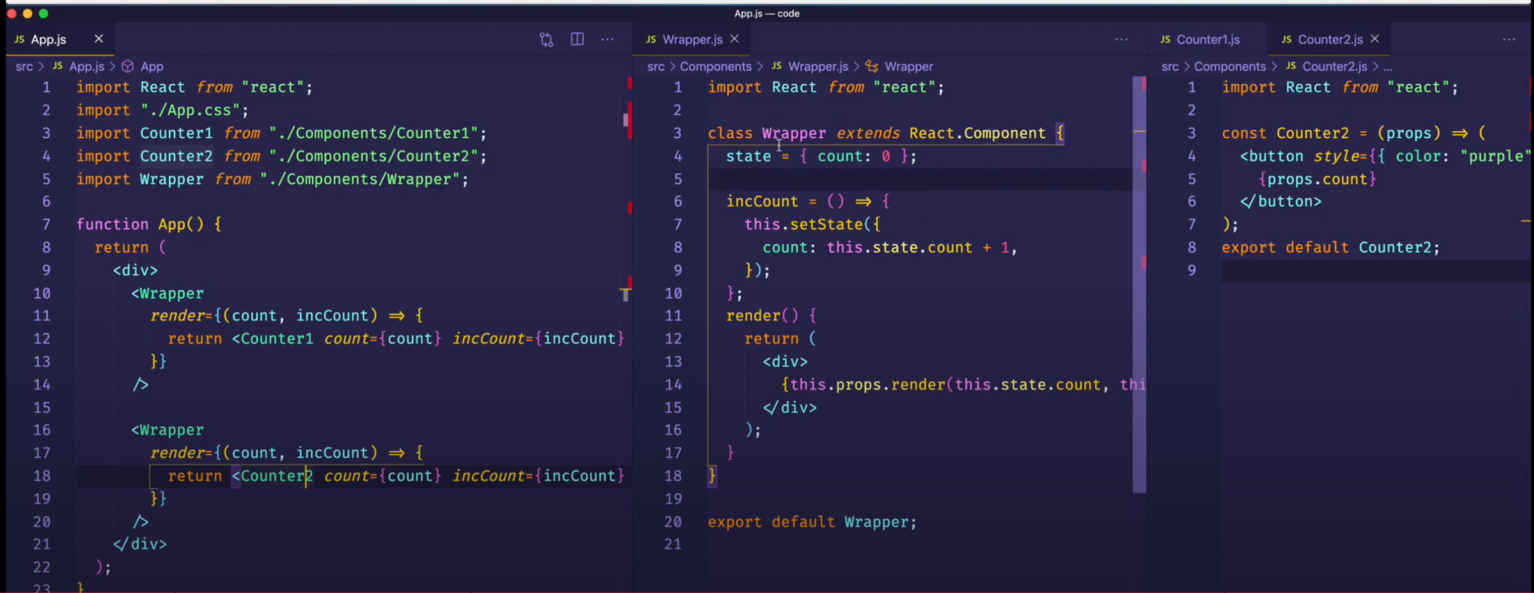

*What is the result of the return statement of the DataFetcher component?*

* *The component returns the result of calling the render function. (That’s correct! The DataFetcher component returns the result of calling the render function and has no other rendering business.)*

## Why React Testing Library

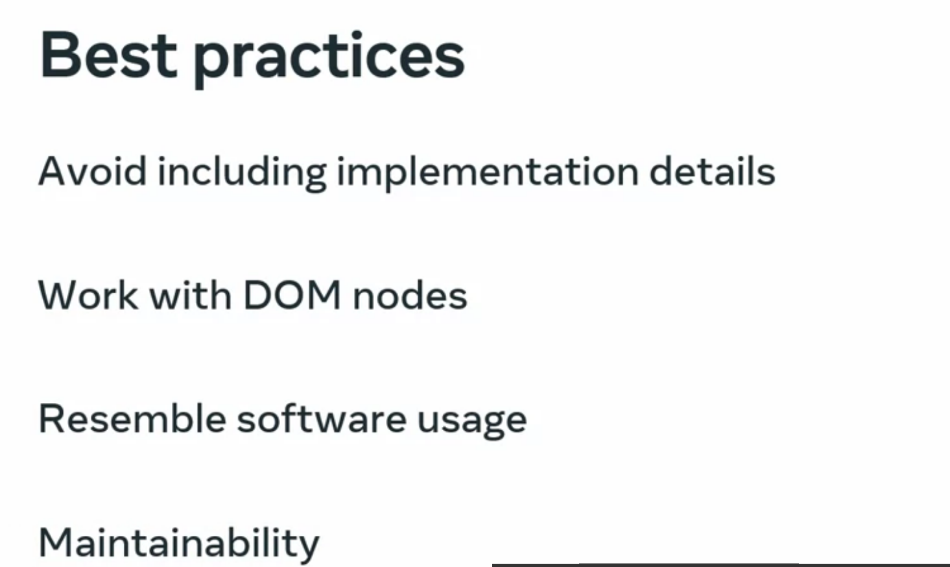



Jest is a JavaScript test runner that lets you access an artificial DOM called JSDOM. While JSDOM is only an approximation of how the browser works, it is often good enough for testing React components. Jest provides a good iteration speed combined with powerful features like mocking modules, so you can have more control over how the code executes. Recall that mocking refers to something made as an imitation, and enables you to replace complex functions from your code with others that are simpler and simulate the same behaviour. Mocking features can be used to make sure that your unit testing is standalone.



The second tool is React Testing Library, which is a set of utilities that let you test React components without relying on their implementation details. React Testing Library has been designed to fulfil all the best practices highlighted before, so that you get a well-configured testing environment out of the box, and are able to focus on the business logic your tests need to run assertions on.

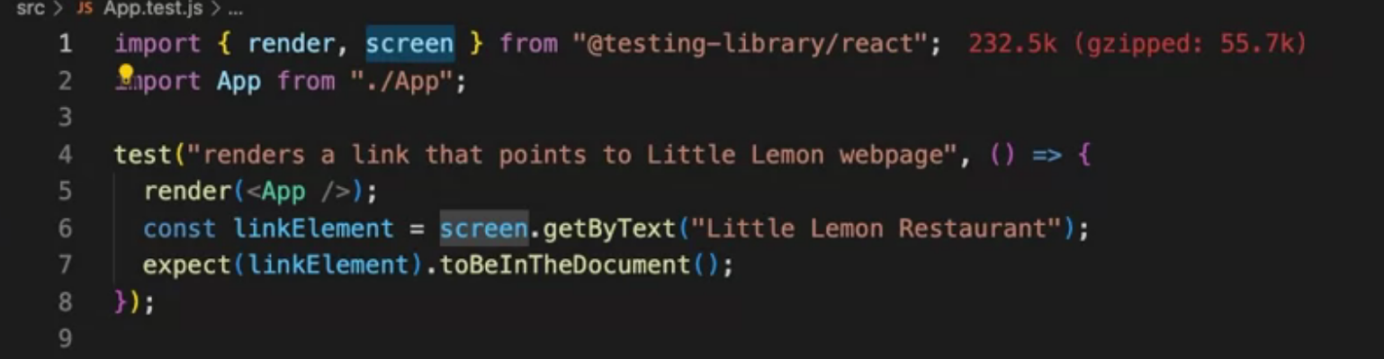

*Which of the following statements are true about Jest and React Testing Library tool? Select all that apply.*

* *React Testing Library is a set of utilities that let you test React components without relying on their implementation details.*
* *Jest is a JavaScript test runner that lets you access an artificial DOM,which provides an approximation of how the browser works.*

## Writing the first test for your form

